# Word Representation

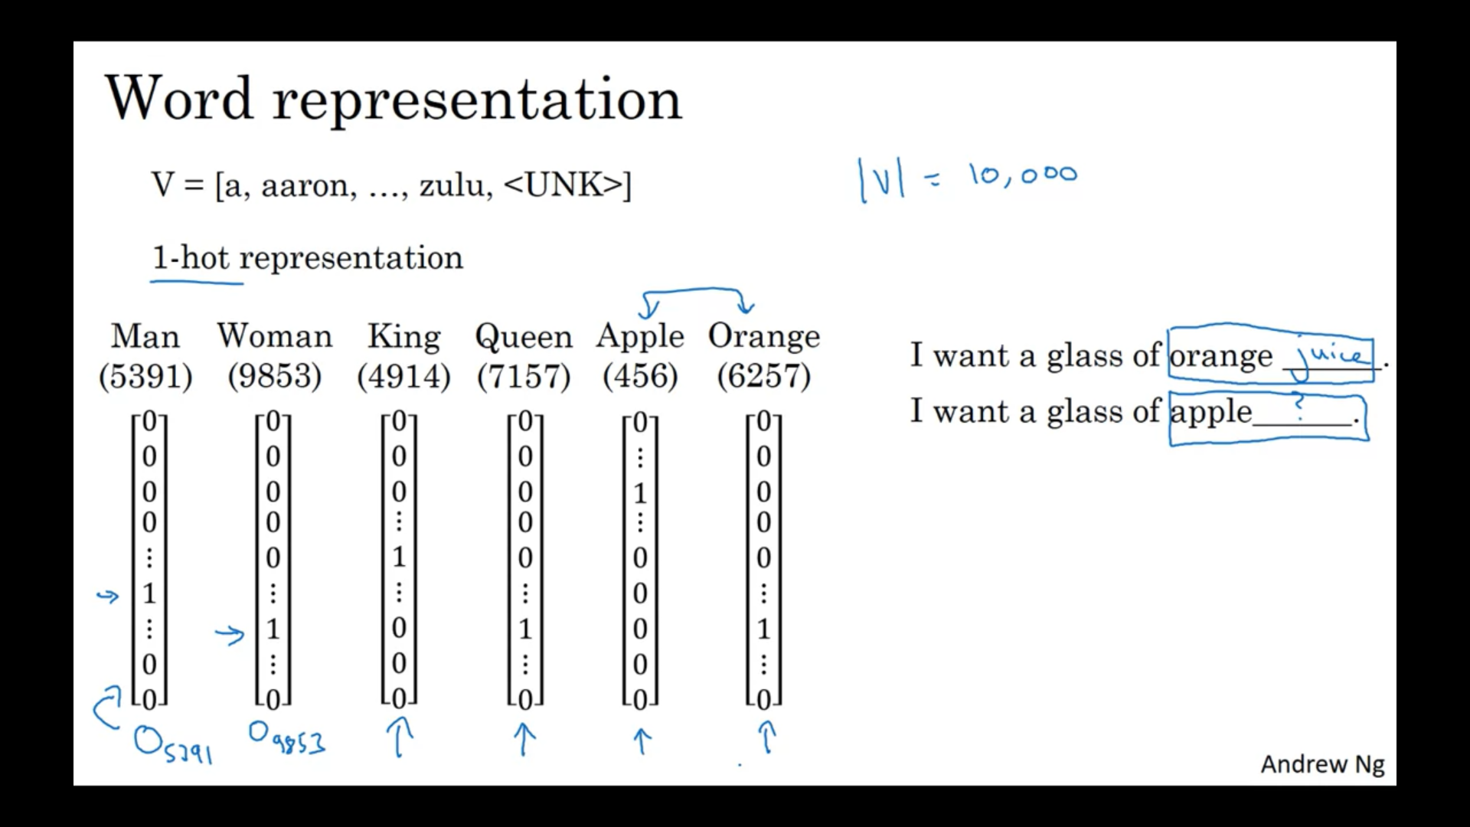

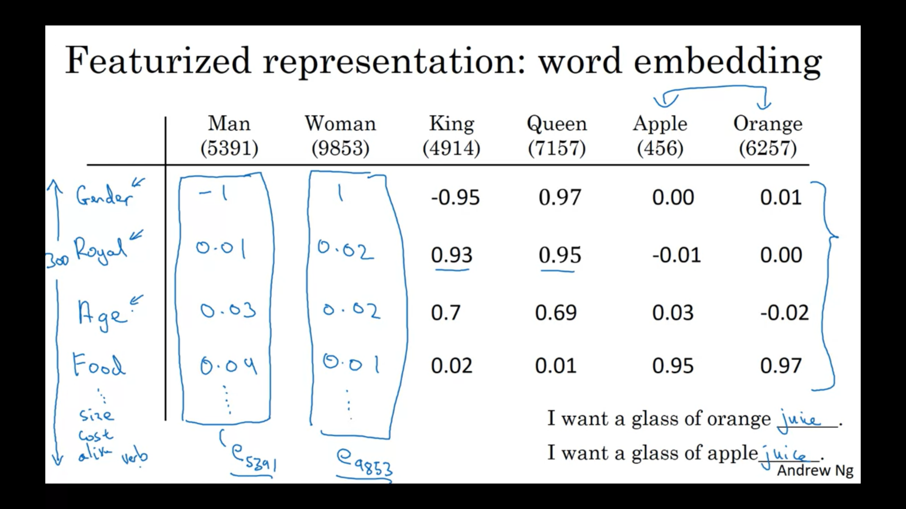

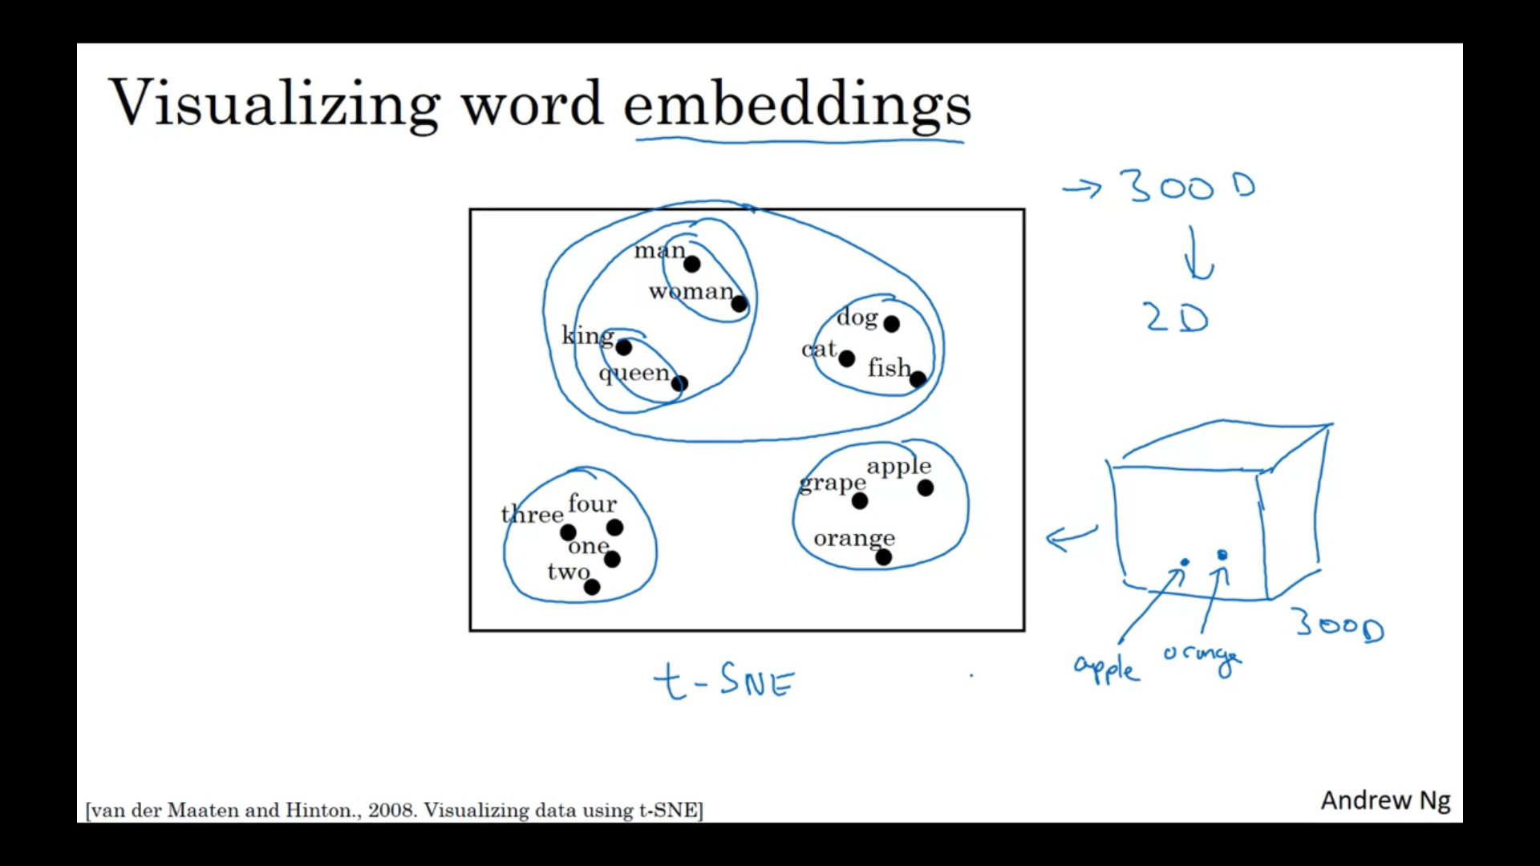

# Using word embeddings

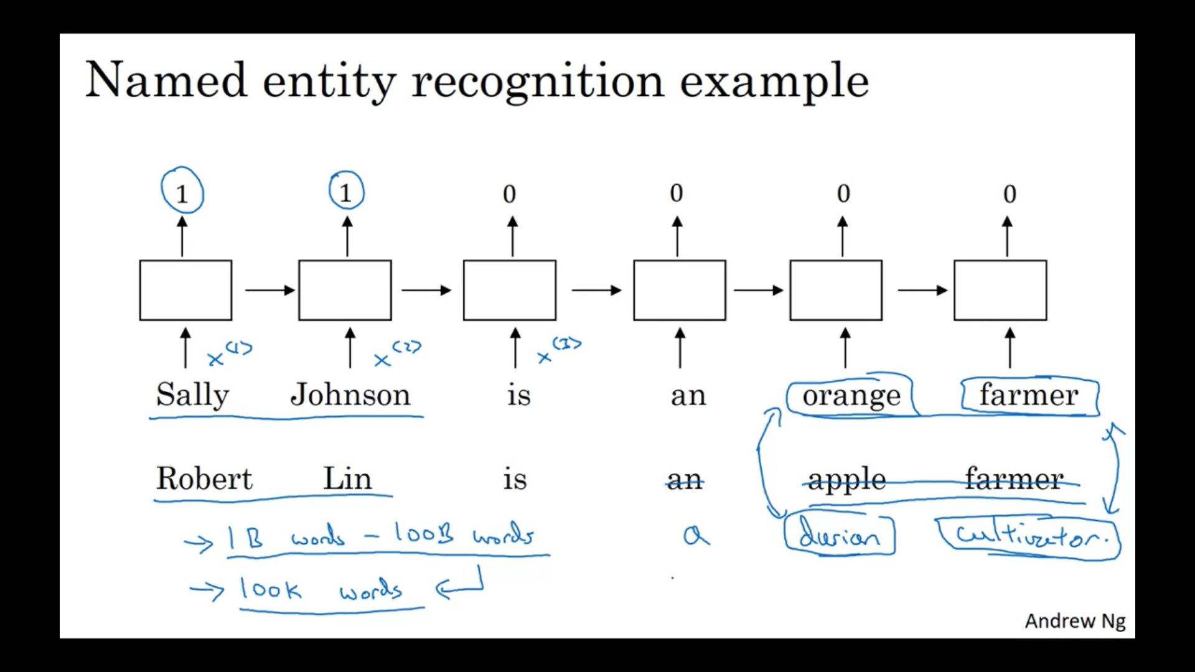

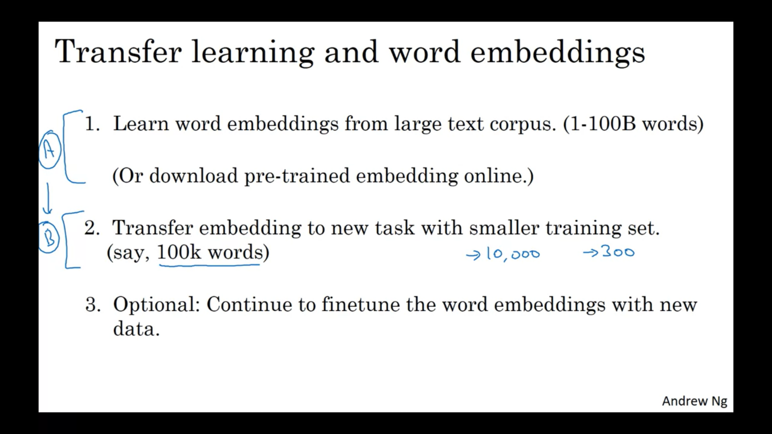

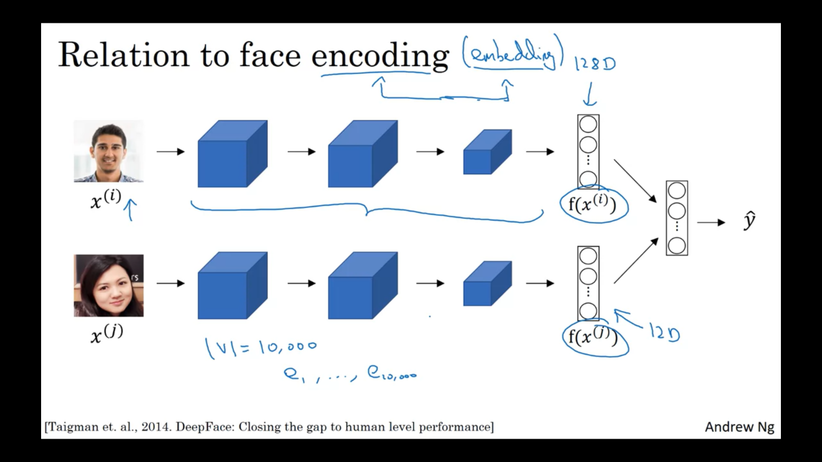

One difference between the face recognition literature and

what we do in word embeddings is that, for face recognition,

you wanted to train a neural network that can take as input any face picture,

even a picture you've never seen before,

and have a neural network compute an encoding for that new picture.

Whereas what we'll do, and you'll understand this better when we go through

the next few videos, whereas what we'll do for learning word embeddings is that

we'll have a fixed vocabulary of, say, 10,000 words.

And we'll learn a vector e1 through, say,

e10,000 that just learns a fixed encoding or

learns a fixed embedding for each of the words in our vocabulary.

So that's one difference between the set of ideas you saw for face recognition

versus what the algorithms we'll discuss in the next few videos.

# Properties of word embeddings

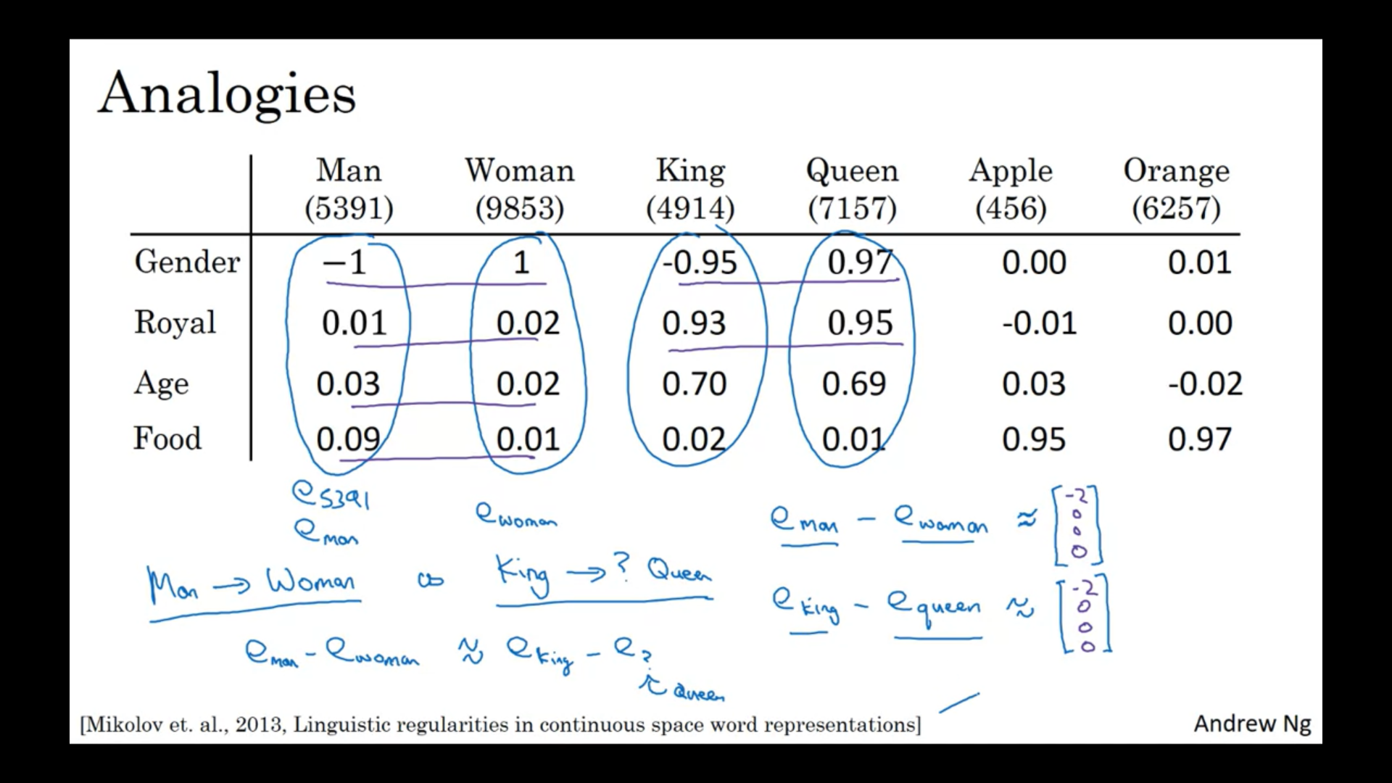

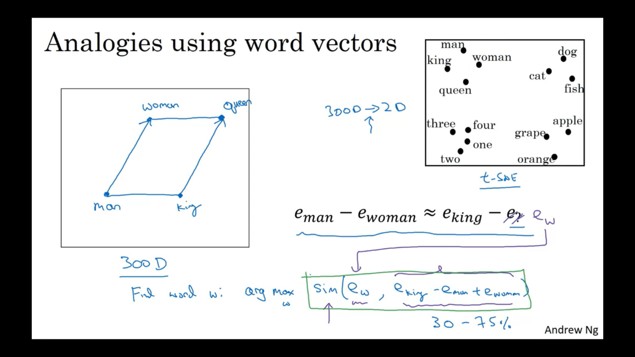

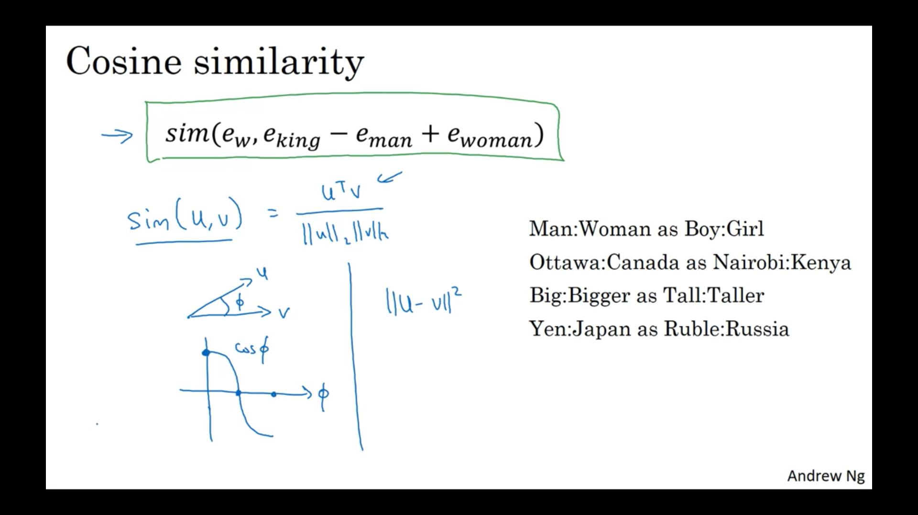

# Embedding matrix

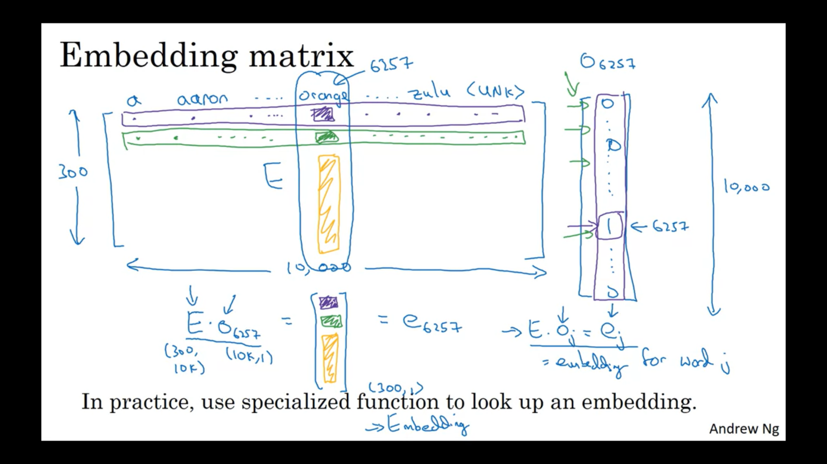

# Learning word embeddings